SIMATS ENGINEERING (SAVEETHA SCHOOL OF ENGINEERING)
Department of Computer Science and Engineering
ASSESSMENT TOOL 3 – Comparative Analysis
Course Code: | CSA06 | Course Title: | Design and Analysis of Algorithms
CO Assessed: | CO4: Articulation (BL4, BL5) | Assessment: | Assessment Tool 3 – Comparative Analysis
Weightage: | 10% of CIA | Total Marks: | 100 (2 Questions × 50 Marks)
CO4 Statement: | Solve optimization problems using dynamic programming and greedy strategies.
Student Name: | S.MAHALAKSHMI | Reg. No.: | 192524372
Section / Batch: | SLOT A | Date: | 24/08/26

Instructions to Students
- Answer both questions carefully. Each question carries 50 marks. Total: 100 marks.
- Analyze the given questions thoroughly before answering.
- Compare multiple aspects such as methods, results, advantages, and limitations clearly.
- Critically evaluate the strengths, weaknesses, and implications with proper justification.
- Present meaningful insights, interpretations, and well-supported conclusions from the comparisons.

Question Type | Description | Questions | Total Marks
Comparative Analysis | Focus on Comparison of different Algorithms using dynamic programming and greedy strategies. | Q1 – Q2 | 100

SECTION A – Comparative Analysis
- Define the Word Break and Longest Palindromic Subsequence problems with suitable examples.
- Write the DP algorithm or pseudocode.
- Prepare the DP table/state representation.
- Develop the recurrence relation
- Implement the Longest Palindromic Subsequence using Dynamic Programming (Saveetha Compiler)
- Analyze time complexity.
- Analyze space complexity.
- Compare the two DP formulations using a table.
- Identify similarities between the two problems.
- Identify differences in state definition and transitions.
- Compare the DP state, transition, implementation, and complexity of both problems and provide a conclusion.

QUESTION 1:
1. Knapsack Comparison (DP vs Greedy)
Given items with weights [10, 20, 30] and values [60, 100, 120] with capacity 50, solve using both 0/1 Knapsack (Dynamic Programming) and Fractional Knapsack (Greedy). Compare the solutions obtained and analyze differences in optimality and approach. Evaluate the strengths and limitations of both methods. Discuss when greedy provides optimal results and when DP is necessary. Generate insights on method selection.

SOLUTIONS:

1. DEFINE THE PROBLEM WITH A SUITABLE EXAMPLE
1.1 0/1 Knapsack — Dynamic Programming
The 0/1 Knapsack Problem is an optimization problem where each item can either be selected completely or not selected at all. The objective is to maximize the total value without exceeding the given capacity.
Given:
- Weights = [10, 20, 30]
- Values = [60, 100, 120]
- Capacity = 50
For example, selecting Item 2 and Item 3 gives:
Weight = 20 + 30 = 50
Value = 100 + 120 = 220
Therefore, the optimal 0/1 Knapsack value is:
220

1.2 Fractional Knapsack — Greedy
In Fractional Knapsack, an item can be divided into fractions. The objective is also to maximize value without exceeding the capacity.
Calculate value/weight ratio:
Item | Weight | Value | Value/Weight
1 | 10 | 60 | 6
2 | 20 | 100 | 5
3 | 30 | 120 | 4
The greedy algorithm selects items according to the highest ratio.
- Item 1 → take completely → value 60
- Item 2 → take completely → value 100
- Item 3 → take 20/30 fraction → value 80
Total:
60+100+80=240

2. DP / ALGORITHM / PSEUDOCODE
2.1 0/1 Knapsack — Dynamic Programming
Knapsack(weights, values, n, W)

Create DP[n+1][W+1]

for i = 0 to n:
for w = 0 to W:

if i == 0 or w == 0:
DP[i][w] = 0

else if weights[i-1] <= w:
DP[i][w] = max(
DP[i-1][w],
values[i-1] + DP[i-1][w-weights[i-1]]
)

else:
DP[i][w] = DP[i-1][w]

return DP[n][W]

2.2 Fractional Knapsack — Greedy
FractionalKnapsack(weights, values, n, W)

Calculate value/weight ratio for every item

Sort items in decreasing order of ratio

total_value = 0

for every item:

if item.weight <= W:
take the complete item
W = W - item.weight
total_value = total_value + item.value

else:
take the fraction that fits
total_value =
total_value + ratio × W
break

return total_value

3. DP TABLE / STATE REPRESENTATION
3.1 0/1 Knapsack DP State
Define:
as the maximum value that can be obtained using the first i items with capacity w.
For the given input:
Items / Capacity | 0 | 10 | 20 | 30 | 40 | 50
0 Items | 0 | 0 | 0 | 0 | 0 | 0
Item 1 | 0 | 60 | 60 | 60 | 60 | 60
Item 2 | 0 | 60 | 100 | 160 | 160 | 160
Item 3 | 0 | 60 | 100 | 160 | 180 | 220
Therefore:

3.2 Fractional Knapsack State
Greedy does not use a DP table.
Instead, it maintains:
Remaining Capacity
Total Value
and selects the item having the maximum:
Step | Item | Weight Taken | Value Obtained | Remaining Capacity
1 | Item 1 | 10 | 60 | 40
2 | Item 2 | 20 | 100 | 20
3 | Item 3 | 20/30 | 80 | 0
Total |  | 50 | 240 | 0

4. RECURRENCE RELATION
0/1 Knapsack
If the item does not fit:
If the item fits:
The algorithm compares include and exclude choices.
Fractional Knapsack
Greedy does not use a traditional DP recurrence.
Its selection criterion is:
Items are selected in decreasing order of this ratio.

5.IMPLEMENT THE LONGEST PALINDROMIC SUBSEQUENCE USING DYNAMIC PROGRAMMING (SAVEETHA COMPILER)

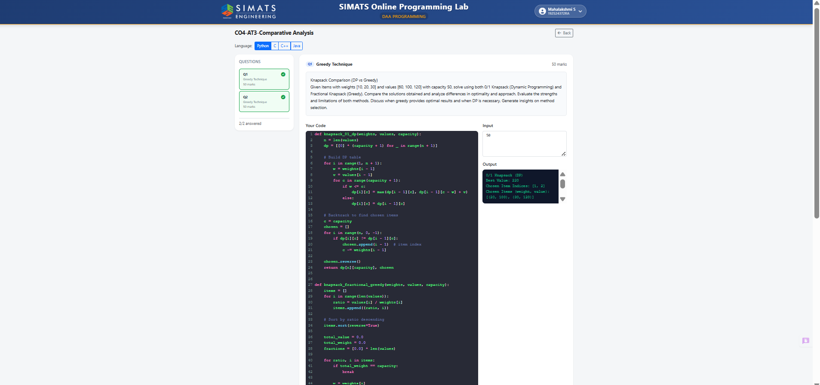

6. TIME COMPLEXITY
0/1 Knapsack
The DP table has n × W states.
Therefore:
Fractional Knapsack
Calculating ratios requires O(n) and sorting requires:
Therefore:

7. SPACE COMPLEXITY
0/1 Knapsack
The DP table requires:
Fractional Knapsack
The items and their ratios require:

8. COMPARISON OF THE TWO FORMULATIONS
Feature | 0/1 Knapsack | Fractional Knapsack
Approach | Dynamic Programming | Greedy
Item division | Not allowed | Allowed
State | DP[i][w] | Value/weight ratio
Result | 220 | 240
Time | O(nW) | O(n log n)
Space | O(nW) | O(n)
Optimality | Optimal for 0/1 | Optimal for fractional
Main operation | Include/exclude | Highest ratio first

9. SIMILARITIES
Both approaches:
- Solve a Knapsack optimization problem.
- Maximize total value.
- Have a capacity constraint.
- Use item weights and values.
- Try to select the most beneficial combination of items.
- Produce an optimal result for their respective problem versions.

10. DIFFERENCES IN STATE AND TRANSITION
State
Dynamic Programming:
represents the maximum value using the first i items with capacity w.
Greedy:
There is no DP state. Instead, items are ranked using:
Transition
DP:
Include item
OR
Exclude item
and take the maximum.
Greedy:
Select the item with the highest value/weight ratio.

11. DP STATE, TRANSITION, IMPLEMENTATION AND COMPLEXITY COMPARISON
Aspect | 0/1 Knapsack — DP | Fractional Knapsack — Greedy
State | DP[i][w] | Remaining capacity + ratio
Transition | Include or exclude | Select highest ratio
Implementation | 2D DP table | Sorting + selection
Time | O(nW) | O(n log n)
Space | O(nW) | O(n)
Divisible items | No | Yes
Optimality | Guaranteed | Guaranteed for fractional case

12. CONCLUSION
The 0/1 Knapsack and Fractional Knapsack demonstrate the difference between Dynamic Programming and Greedy algorithms.
For the given input:
Greedy provides an optimal solution for Fractional Knapsack because items can be divided and selecting the highest value/weight ratio first is guaranteed to be optimal.
However, greedy is not generally optimal for 0/1 Knapsack. Dynamic Programming is required because it considers both including and excluding an item and evaluates different combinations.
Therefore, Greedy should be selected when the problem has the greedy-choice property, while Dynamic Programming should be selected when local greedy decisions cannot guarantee a globally optimal solution.

QUESTION 2:

2. Shortest Path Comparison (Dijkstra vs Bellman-Ford)
Given a graph with edges including negative weights, apply both Dijkstra’s and Bellman-Ford algorithms to compute shortest paths. Compare their correctness, complexity, and limitations. Critically evaluate why Dijkstra fails in certain cases. Analyze performance differences and derive insights on algorithm selection.

SOLUTIONS:

1. DEFINE THE PROBLEM WITH A SUITABLE EXAMPLE
The Shortest Path Problem finds the minimum-cost path from a source vertex to other vertices in a weighted graph.
Consider the following graph:
A → B = 2
A → C = 5
C → B = -10
B → D = 2
C → D = 4
Source vertex:
A
The graph contains a negative edge:
C → B = -10
The actual shortest path from A to B is:
A → C → B
with cost:
5+(−10)=−5
The shortest path from A to D is:
A → C → B → D
with cost:
5−10+2=−3

2. ALGORITHM / PSEUDOCODE
2.1 Dijkstra's Algorithm
Dijkstra(Graph, source)

Set distance[source] = 0

Set all other distances = infinity

while unvisited vertices exist:

Select the unvisited vertex
with the smallest distance

Mark it as visited

for each neighbor v:

new_distance =
distance[u] + weight(u,v)

if new_distance < distance[v]:

distance[v] = new_distance

return distances
Important condition
Dijkstra requires:
All edge weights must be non-negative.

2.2 Bellman-Ford Algorithm
BellmanFord(Graph, source)

Set distance[source] = 0

Set all other distances = infinity

Repeat V-1 times:

for every edge (u,v):

if distance[u] + weight(u,v)
< distance[v]:

distance[v] =
distance[u] + weight(u,v)

Check all edges again

If any distance can still be reduced:

Negative cycle exists

return distances

3. STATE REPRESENTATION
Both algorithms maintain a distance array.
Initial state:
Vertex | A | B | C | D
Distance | 0 | ∞ | ∞ | ∞
Here:
dist[A] = 0
dist[B] = ∞
dist[C] = ∞
dist[D] = ∞
4. Recurrence / Relaxation Relation
Bellman-Ford uses:
For example:
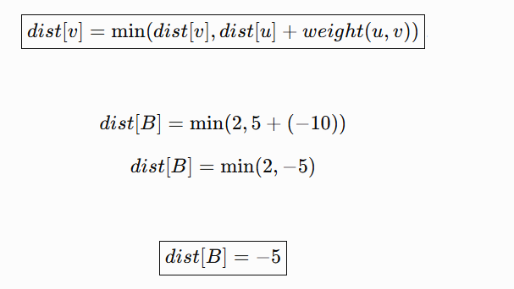
Dijkstra does not use this repeated DP-style relaxation over all edges. It selects the vertex with the smallest current distance and then relaxes its outgoing edges.

5. DP / STATE TABLE
Bellman-Ford
Vertex | Initial | After Relaxation | Final
A | 0 | 0 | 0
B | ∞ | -5 | -5
C | ∞ | 5 | 5
D | ∞ | -3 | -3
Final shortest distances:
Destination | Shortest Distance | Path
A | 0 | A
B | -5 | A → C → B
C | 5 | A → C
D | -3 | A → C → B → D

6. IMPLEMENTATION

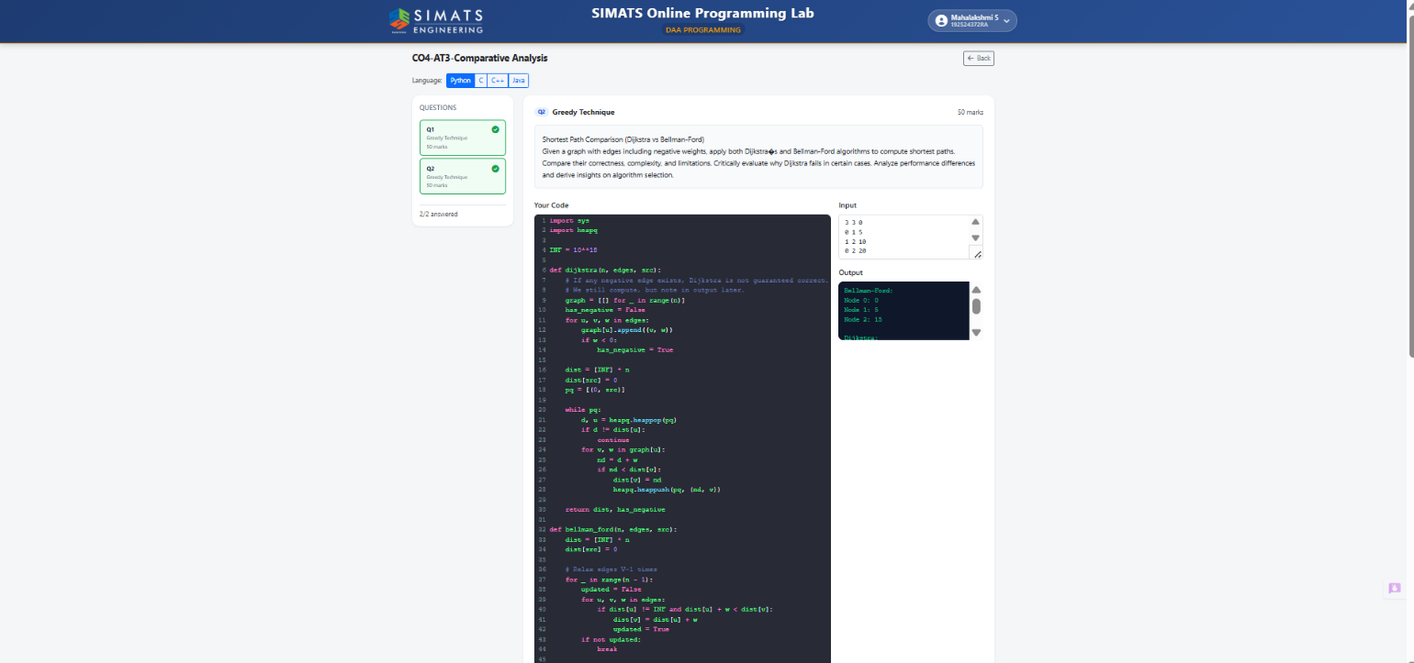

7. TIME COMPLEXITY
Dijkstra
Using a simple array:
Using a priority queue:
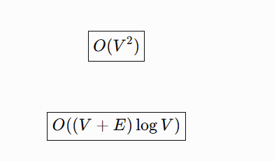
Bellman-Ford
O(V E)
Bellman-Ford relaxes all edges V-1 times:
Therefore, Dijkstra is generally faster.

8. SPACE COMPLEXITY
Dijkstra
With adjacency-list representation: O( V +E)
Bellman-Ford
For storing vertices, edges and distances: O(V +E)

9. COMPARISON OF THE TWO ALGORITHMS
Feature | Dijkstra | Bellman-Ford
Approach | Greedy | Repeated relaxation
Negative edges | ❌ Not safely supported | ✅ Supported
Negative cycles | ❌ Cannot detect | ✅ Can detect
Time | O((V+E) log V) | O(VE)
Space | O(V+E) | O(V+E)
Speed | Faster | Slower
Correct for negative edges | ❌ Not guaranteed | ✅ Yes
Main strength | Fast | Handles negative weights
Main limitation | Negative edges | Higher time complexity

10. SIMILARITIES
Both algorithms:
- Find shortest paths from a source.
- Maintain distance values.
- Use weighted edges.
- Update distances when a shorter path is found.
- Can handle graphs containing positive edge weights.
- Can be used for single-source shortest-path problems.

11. DIFFERENCES IN STATE AND TRANSITION
Dijkstra State
dist[v]
represents the currently known shortest distance to vertex v.
Its main decision is:
Select the unvisited vertex with minimum distance.
Bellman-Ford State
dist[v]
also represents the shortest known distance to v.
However, Bellman-Ford repeatedly performs:
for every edge.
Main Difference
Dijkstra:
Choose minimum → finalize → relax
Bellman-Ford:
Relax all edges → repeat → improve distances

12. DP STATE, TRANSITION, IMPLEMENTATION AND COMPLEXITY COMPARISON
Aspect | Dijkstra | Bellman-Ford
State | dist[v] | dist[v]
State meaning | Current shortest known distance | Shortest distance after repeated relaxation
Transition | Select minimum-distance vertex | Relax every edge
Main operation | Greedy selection | Minimum distance relaxation
Implementation | Priority queue / minimum selection | Repeated edge relaxation
Time | O((V+E) log V) | O(VE)
Space | O(V+E) | O(V+E)
Negative edges | Not supported safely | Supported
Negative-cycle detection | No | Yes

13. WHY DIJKSTRA FAILS IN THIS EXAMPLE
This is the critical point for your question.
Initially:
A = 0
B = 2
C = 5
D = ∞
Dijkstra sees:
B = 2
C = 5
and selects B because:
It assumes B's distance is final.
But there is another path:
A → C → B
whose cost is:
So the actual shortest distance is:
not:
The negative edge allows a path through a vertex that initially appeared more expensive to later become cheaper.
This violates Dijkstra's greedy assumption.

14. PERFORMANCE ANALYSIS
Situation | Better Algorithm
Large graph + non-negative edges | Dijkstra
Negative edge weights | Bellman-Ford
Need negative-cycle detection | Bellman-Ford
Need faster execution | Dijkstra
Correctness with negative edges | Bellman-Ford

15. ALGORITHM SELECTION
Select Dijkstra when:
- All weights are non-negative.
- The graph is large.
- Speed is important.
- Efficient shortest-path calculation is required.
Select Bellman-Ford when:
- Negative edges are present.
- Negative cycles must be detected.
- Correctness is more important than speed.

16. CONCLUSION
Dijkstra and Bellman-Ford both solve the shortest-path problem, but they are designed for different conditions.
For the given graph containing a negative edge, Bellman-Ford is the appropriate algorithm because it can correctly process negative weights and detect negative cycles.
Dijkstra is generally faster, but its greedy strategy depends on all edge weights being non-negative.
Therefore:
Dijkstra should be selected for speed when all edge weights are non-negative, while Bellman-Ford should be selected when negative edge weights are present or negative-cycle detection is required.

Final Comparison of Your TWO Questions
Required Content | Knapsack: DP vs Greedy | Shortest Path: Dijkstra vs Bellman-Ford
Problem definition | 0/1 & Fractional Knapsack | Single-source shortest path
Example | [10,20,30], capacity 50 | Graph with negative edge
DP/Algorithm | DP + Greedy | Dijkstra + Bellman-Ford
State | DP[i][w] | dist[v]
Transition | Include / exclude | Relaxation / minimum selection
Result | DP = 220, Greedy = 240 | Bellman-Ford gives correct negative-edge result
Time | DP O(nW), Greedy O(n log n) | Dijkstra O((V+E)logV), BF O(VE)
Space | DP O(nW), Greedy O(n) | Both O(V+E)
Similarity | Both optimize under constraints | Both find shortest paths
Main difference | Greedy vs DP | Greedy vs repeated relaxation
Main limitation | Greedy not optimal for 0/1 | Dijkstra fails with negative edges
Best selection | DP for 0/1, Greedy for Fractional | Dijkstra for non-negative, BF for negative

Code of Conduct
I S.MAHALAKSHMI(192524372)__________________________ (Name / Reg No) certify that this submission is my original work and that I have adhered to the guidelines specified for this assessment. I understand that any violation of academic integrity rules will result in disciplinary action.
Signature of the Student: S.MAHALAKSHMI_________________________

RUBRICS FOR CALCULATION

Comparative Analysis
Criteria | Weightage | Level 4 (Exemplary) | Level 3 (Proficient) | Level 2 (Developing) | Level 1 (Beginning)
Selection of Studies/Parameters | 20% | Selects highly relevant and diverse studies with well-defined comparison parameters | Selects relevant studies with minor gaps in parameter definition | Limited or partially relevant selection | Poor or inappropriate selection of studies
Comparison & Differentiation | 25% | Clearly compares multiple aspects (methods, results, limitations) with strong differentiation | Good comparison with minor gaps | Basic comparison with limited depth | No clear comparison; mostly descriptive
Critical Evaluation | 25% | Critically evaluates strengths, weaknesses, and implications with strong justification | Provides evaluation with some justification | Limited evaluation; lacks depth | No critical evaluation provided
Synthesis & Insight Generation | 20% | Generates meaningful insights and conclusions from comparisons | Some insights derived from comparison | Limited or unclear insights | No insights generated
Clarity | 10% | Information is clearly presented (tables/figures) with logical structure | Generally clear with minor issues | Presentation lacks clarity or structure | Poor presentation and difficult to understand

Mark Evaluation:
Questions | Selection of Studies/Parameters (20) | Comparison & Differentiation  (25) | Critical Evaluation (25) | Synthesis & Insight Generation  (20) | Clarity (10) | Total Marks  (Each - 50)
Q1
Q2
Overall Total

Faculty In-charge | Course Coordinator | Head of Department
Name: __________________  Signature: _______________ | Signature: _______________ | Signature: _______________
Date: ___________________ | Date: ___________________ | Date: ___________________

